Technical Design II
Contents
- Introduction
- Technology Stack
  - Language and Frameworks
  - Web Application Templating Engine
  - Authentication and Authorisation
  - Database Transactions
- Technical Design
  - Authentication and Authorisation
  - Trades
  - Reports
  - Stock Value Generator
- References

Introduction
This document proposes a technical design for the product described in the FDM05 Project Brief. It follows a breakdown of the fundamental design goals and functionality that the developer should use and reference to create a real-time stock trading simulator.

Technology Stack
The implementation of the stock trading simulator will expand on the technologies used in the first project, which used known standards for web applications.

Language and Frameworks
Java with Spring Boot was used in the previous project to develop a basic web application. This design will also use Java and Spring Boot but the following also explore alternative technologies that solve common problems.
The Spring framework provides multiple libraries to assist developers avoid boiler plate code. Spring Boot and Spring MVC cover required code to run an embedded server and servlet containers, and simple templates with which to set up web projects. This means a developer need not write any code to launch a simple 'Hello World'-like web application.
Spring also includes projects, such as Spring Security and Spring Data, that can enable the project to quickly set up the required for web sessions, encryption, entity validation and database CRUD. However, because Spring covers boilerplate code and provides standards for its framework, it is a highly opinionated framework which may not always suit the problem best. Though the project will use Spring Boot for the given reasons, the technology stack choices was also weighed against any Spring counterparts.

Web Application Templating Engine
The client technology stack has mostly already been defined by the project brief. AJAX will be employed for users to request data such as paginated stock listings. It was stated that real-time stock information should ideally be sent by the server. This can be done through Server Send Events (as opposed to client to server requests such as long polling). These will be combined with jQuery to cover remaining logic. The appearance will be covered by HTML and CSS.
A templating engine will be used to avoid duplication of code and mark-up. It is also required to assist consistency to all pages. For instance, every page should have the same navigation bar. By using a templating language, we avoid missing a single page from editing and all the pages become much easier to maintain as only a single file is changed.
A templating language allows us to use separation of concerns and single responsibility principles in our mark up. A single file can be responsible for only one part of a webpage design and we need only touch that file should we wish to make a modification.
Thymeleaf and FreeMarker are both supported by Spring. Although FreeMarker was chosen in the previous project to use as the templating engine, Thymeleaf will be used in this project.
Thymeleaf has a fundamentally different philosophy to that of FreeMarker as it is based on mark-up parsing rather than procedural-like text processing of syntax. The natural templating allows decoupling, similar to Spring annotations. This means that even if Thymeleaf is not actively used, the document itself is still valid and does not break due to the templating engine being removed.
It is also supported by Spring by default and all Spring tutorials that use webpages reference Thymeleaf. When implementing pages that use Spring functionality, it is therefore much simpler to follow the tutorial than to translate the mark-up to fit a different engine’s syntax.

Authentication and Authorisation
Both authentication and authorisation are required in the project. A user must be authenticated by username and password to access privileged areas of the simulator. Secondly, there are admin privileges that only a user with an administrator role should be able to access. We therefore need to be able to verify:
- If the user has access to the system
- To what parts of the system the above user has access
Shiro is designed to be as simple as possible, specifically to be easier to implement than JAAS. It aims to be decoupled from the main application and equally aims to be injected to existing web applications effortlessly. This design will expect Shiro to be used as opposed to JAAS or Spring Security.
Spring Security provides the same functionalities as Shiro. Namely, both provide interfaces to authenticate users, persistent-logging, encryption, and authorisation. As previously mentioned, Spring Security is highly opinionated and though its classes are decoupled from the larger framework, they are not necessarily expected to be decoupled.
For instance, Spring Security's AuthenticationProvider has a UserDetailsService class that provides the username and password to the requester. The UserDetailsService interface suggests the use of Service interfaces to provide data from the database in a controlled way, perhaps to a Provider. Breaking from this pattern is perfectly possible but inconsistent.
Not only this but the default UserDetailsService implementation is a concrete DAO class, suggesting that Service interfaces should be implemented by DAOs rather than using DAOs as class or member variables. Other implementations of the UserDetailsService similarly have strong suggestions of what design patterns should be used and give less flexibility to the overall program in the interest of consistency and maintainability.
Shiro thus has a further benefit in that it is not interested in how its UsernamePasswordToken is populated. Shiro is only interested in security unlike Spring which has opinions on security, database access, MVC, etc.
The actual process of storing credit card information against a user is typically done through a payment gateway, such as PayPal or Authorize.Net. In real-life business situations, these payment gateways would handle authentication and security. It is far easier and avoids many risks, e.g. card fraud, database hacking, and privilege abuse (Solomon, 2014) to allow such third-parties to handle credit card information, and rely on them to abide by PCI standards (PCI Security Standards Council, 2016). As the product is a simulation and the project requirements specifically state how credit card information should be stored in the database, this design will not consider PCI standards within the scope of the project.

Database Transactions
MySQL will be used as the RDBMS. As a free and standard product, it has wide-spread usage and pervasive number of tutorials.
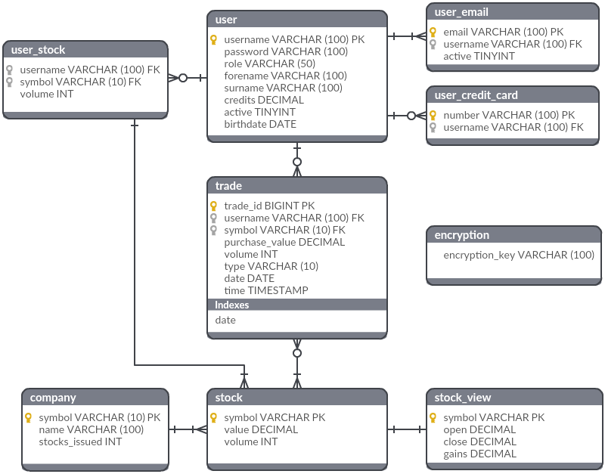
Figure 1 – Real-Time Stock Simulator ERD
The tables in Figure 1 have been designed to address:
- User registration
  - User accounts are active or inactive based on:
    - Email validation
    - Credit card details
    - Stock count and available credits
    - User banishment by the administrator
- Report and stock listing details
  - Company stock listings
  - Stock reports requiring current, open, and close values
  - Stock reports requiring gains
  - Last trade details
- Account details
  - User owned stocks
  - Previous transactions
- Encryption
  - The encryption key should be stored on the database as per the Project Brief
Spring Data can perform Object Relational Mapping (ORM) with annotated Java classes and provide the ability to create DAO interfaces. However, this design has chosen not to use Spring Data due to its highly opinionated nature. The design will be service-oriented, containing services that address the required DML for functionality.
For instance, a UserService could contain a UserDAO class. As mentioned in Authentication and Authorisation above, Spring provides a UserDetailsService. This class is implemented by Spring with a UserDetailsManager interface, which is implemented by the DAO, or alternatively the service interface itself is implemented by a DAO.
The design pattern provided by Spring suggests that services should be interfaces implemented by DAOs, which is inconsistent with the project's design shown in Figure 2, and is thus avoided.
In a similar way to choosing Shiro over Spring Security, Hibernate will be used, without Spring Data, to map the classes to the databases, where the benefit is that the selected technology addresses only the one subject – database access.
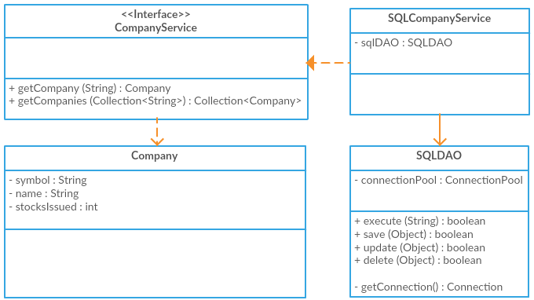
Figure 2 – CompanyService and SQLDAO class diagramme
Figure 2 shows an example of multiple service interfaces defined to address different types of entity access. These are realised by concrete classes with a handle on a DAO, determined by database type.
The DAO object has basic CRUD methods which are exposed to the service so the service may run any necessary query. The DAO accesses the database through a connection pool which can support multi-threading through the application.
The nature of a web application requiring access to a database means that connections will need to be available for the database. Multiple connections are needed to support multiple users. A connection pool should be used as opening connections for every request can use unnecessary resources and become time consuming.
This project will use the widely used DBCP (Apache, 2016) to implement database connection pooling due to its support and documentation. This is in comparison to a library such as C3P0 (Machinery for Change, 2015), last updated January 2015, suggesting less likely support and thus more difficult to maintain.

Technical Design
Authentication and Authorisation
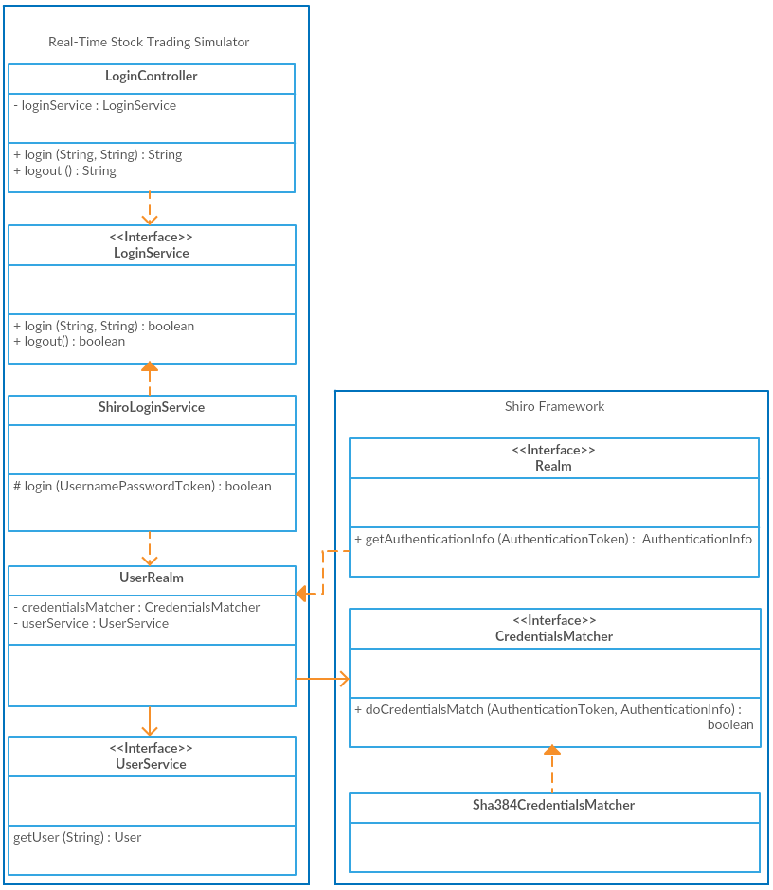
Figure 3 – Shiro security implementation
Security is decoupled from the project, connecting through the LoginService. Interface segregation is used to define service-specific interfaces where realisations express how the service is implemented. For instance, Figure 3 shows the LoginService realised by the ShiroLoginService, i.e. a LoginService using Shiro for authentication and authorisation. Alternatively, a SpringLoginService might be realised, such as by extending the UserDetailsService, or using a concrete implementation that held a UserDetailsService as a class variable.
Calling the Shiro framework is simple – After instantiating a SecurityManager, the ShiroLoginService can construct a UsernamePasswordToken and call its login method. When the login method is called on the token, Shiro uses a Realm, defined in a properties file, to authenticate that user. Figure 3 shows this being done through the UserRealm, which provides the necessary through the project's UserService.
[main]
sha384CredentialsMatcher = org.apache.shiro.authc.credential.Sha384CredentialsMatcher
realm = com.company.tradingsimulator.security.UserRealm
realm.username = username
realm.password = password
realm.credentialsMatcher = $sha384CredentialsMatcher
Figure 4 – Example Shiro realm ini configuration
Shiro's hashing algorithms and password matching allows us to implement one-way encryption for passwords. Again, this is configured in a properties file that the Shiro SecurityManager reads to determine if any encryption should be performed to the password string before validating against stored database passwords.

Trades
Trades are mediated by the Broker. The Broker takes advantage of service dependency inversion, containing the services it needs as class variables. There is high cohesion between the Broker and its services but it is decoupled from the way that these services accomplish their methods. The services will be implemented by SQL realisations, e.g. SQLTradeService. These will be implemented in similar ways to Figure 2, providing a single levelled DIT.
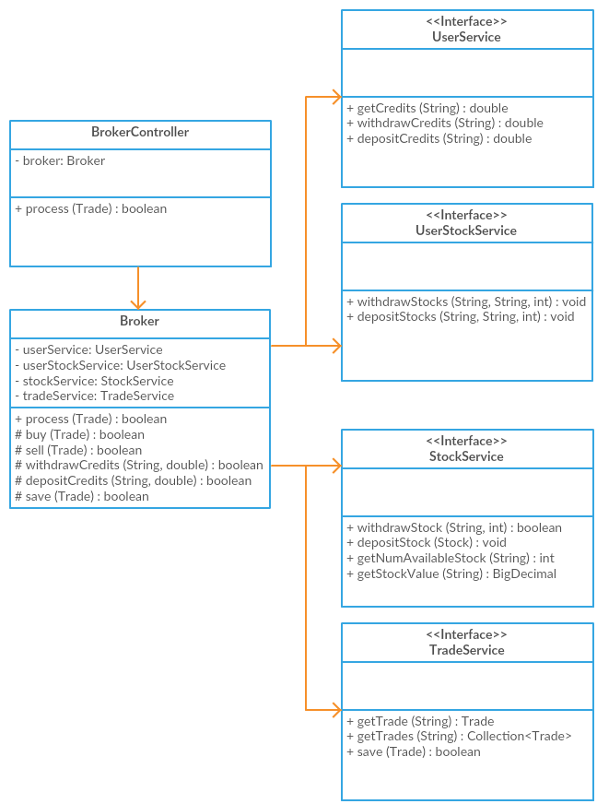
Figure 5 – Broker class diagramme
The Broker is expected to receive trade requests through the BrokerController, which is called by the trade view. When called, it should
- Identify the TransactionType, i.e. TransactionType.BUY or TransactionType.SELL
- In the case of a buy request
  - The broker should withdraw the user credits immediately through the UserService
    - This should be a single conditional request to avoid database locks
  - Withdraw stocks through the StockService
    - This should be a conditional request
    - If a withdraw cannot be performed, the credits should be deposited back into the User’s account
- In the case of a sell request
  - Withdraw user stock with the UserStockService with a conditional request
  - Withdraw stock from the available stocks via the StockService with a conditional request
    - If this cannot be completed, return the user stock to the user
  - Deposit credits to the User with the UserService
- Save the trade by way of the TradeService

Reports
Report generation is designed similar to that of the Broker, in that the ReportGenerator takes advantage of the interface service design. The ReportGenerator relies on dependency inversion of the interfaces and trusts that the concrete implementations will provide the data it needs. It does not matter how the implementations achieve this, thus accomplishing low coupling with high cohesion.
A ReportController is expected to map a user request to a ReportRequest object to pass to the ReportGenerator. The ReportRequest contains a ReportName Enum which the ReportGenerator can identify with a method. For instance, a ReportRequest with ReportName ‘UserStock’ can be identified by the ReportGenerator, with a switch statement, to the getStocksByUser(String, String) method.
The logic to maintain the report definitions is maintained in the report generator, maintaining the single responsibility principle to encapsulate responsibility entirely within a single class. Should report generation change in any way, only this class would need to be modified.
Project requirements state reports should be ordered, whether by company name or stock value, and whether in ascending or descending order. To achieve this, the ReportGenerator and Service methods allow String objects passed into their methods that define the expected order of results. Additionally, List’s rather than Collection’s are used for this reason.
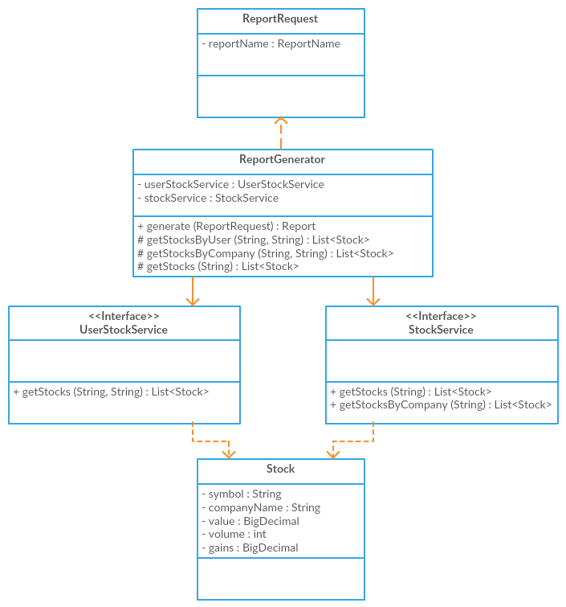
Figure 6 – ReportGenerator class diagramme

Stock Value Generator
Stock generation is designed so it can run as part of the existing project or as a separate process. The StockGenerationService realisations, such as in Figure 7, reflect how they will deliver stock generation and modulation, and will also need to implement how this is done separate to the main stock simulator.
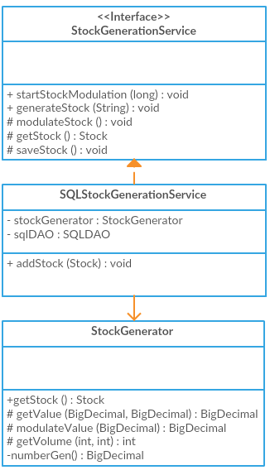
Figure 7 – StockGenerationService class diagramme
The expectation in this project is to keep the implementation as simple as possible. Rather than running the StockGenerationService as a separate process, it can be implemented simply by running background threads.
The realisation of the StockGenerationService should meet its expectations, as consistent with the Liskov Principle, of being able to modulate stock values as well as allow callers to generate stock for a given company. The functionality for these are provided through the methods startStockModulation(long), which should allow stock modulation to occur every given x milliseconds, as well as generateStock(String), which will generate stock given a set of rules for a company symbol.
For this specific project, startStockModulation(long) should be handled in a scheduled thread, such as by a ScheduledExecutorService. Separately, another thread should be able to handle a call to generateStock(String). For instance, a company should be able to register with the simulator, at any given time, and their generated stocks should enter the market in at least 1 second, as per the design goal recommendations.
This must be implemented through a connection pool that the SQLDAO is expected to use to handle multiple requests from multiple clients, as defined in the technology stack.
References
Apache (2016) DBCP – Overview [online], https://commons.apache.org/proper/commons-dbcp/ (Accessed 19 June 2017)
Gosling et al. (2014) The Java Language Specification, Java SE 8 Edition Oracle America, Inc.
Machinery for Change, Inc. (2015) c3p0 – JDBC3 Connection and Statement Pooling [online], http://www.mchange.com/projects/c3p0/ (Accessed 19 June 2017)
Microsoft (2007) C# Guide [online], https://docs.microsoft.com/en-us/dotnet/articles/csharp/ (Accessed 11 April 2017)
PCI Security Standards Council (2016) PCI DSS Agreement [online], https://www.pcisecuritystandards.org/document_library?category=pcidss&document=pci_dss (Accessed 14 May 2017)
Solomon (2014) Your Database is NOT your Credit Card Vault. Here is why [online], https://www.chargebee.com/blog/db-credit-card-vault/ (Accessed 14 May 2017)
Wozniak (2016) Java: Benchmark Thymeleaf 2.1.4 vs Thymeleaf 3.0 SNAPSHOT [online], https://smarterco.de/java-benchmark-thymeleaf-2-1-4-vs-thymeleaf-3-0-snapshot/ (Accessed 11 April 2017)

